Global Temperature Frequencies vs Solar Tide Frequencies

by Volker Doormann
INTRODUCTION

There is a lot of work of climate models done extrapolating the global climate into the future. But most of the models dealing with monotone rising temperature levels, while the character of the well known temperature spectra do show many global temperature frequencies ranging from months to millennia. There is also an intensive discussion about the height of the global temperature level between now and about 900 years ago, or prior to that time, but it seems that there is no mechanism or natural structure discussed, which effects the heat periods from a physical heat source. Many other cycles are named of different year length, like ‘de Vries/Suess-‘ , or ‘Gleissberg- cycle. But there is ever only a cycle length in years and no mechanism and no phase data given to a date of time. It seems that the cycle functions are taken as a sinusoidal function, but the temperature function must not be a sinusoidal function, other complex functions are also possible. This is also evident from the saw tooth like global temperature functions in the last million years, which have relative quick increasing times of a few ky but relaxing times up to 100 ky. Moreover it is known that these saw tooth like phases are time fixed periods of specific times in ky like 41 ky or 94 ky. Whatever the reason for this saw tooth like oscillation is, the large number of periods suggests that there is a hidden geometry structure behind, which is proposed as an inner process in the sun [arxiv.org/pdf/astroph/07011171]. But also the global temperature reconstructions from J. A. Eddy in 1976 [http://bill.srnr.arizona.edu/classes/182h/Climate/Solar/Maunder%20Minimum.pdf] or from Bond et al. in 2001 shows a long temperature time period of about 900 years. In this posting this period of warm times and other faster temperature periods and its phases in date of time will be shown as connected to synodic solar tides from planetary couples, while the strength of the impact is taken from the square root of the inverse tide frequency, as it can be shown also for the power spectrum of analysed temperature reconstructions.
GLOBAL TEMPERATURE FREQUENCIES
Analysing global temperature spectra with the fast method of Fourier FFT, there is a general problem, because it is not easy to say whether a discrete power peak indicate a real cycle; it can also be that the discrete power peak is part of a complex function of a non sinusoidal function, like a rectangle function or a function with higher harmonics to the main frequency. But there is an interesting output from FFT analysed temperature spectra about the character of the frequency dependence of the power peaks, which says that the strength of the temperature power is mostly inverse to the square root of the temperature frequency; a power peak of a 1000 year period is 10 times stronger as a power peak of 10 year period. This indicates a physical nature of the global temperature frequencies.

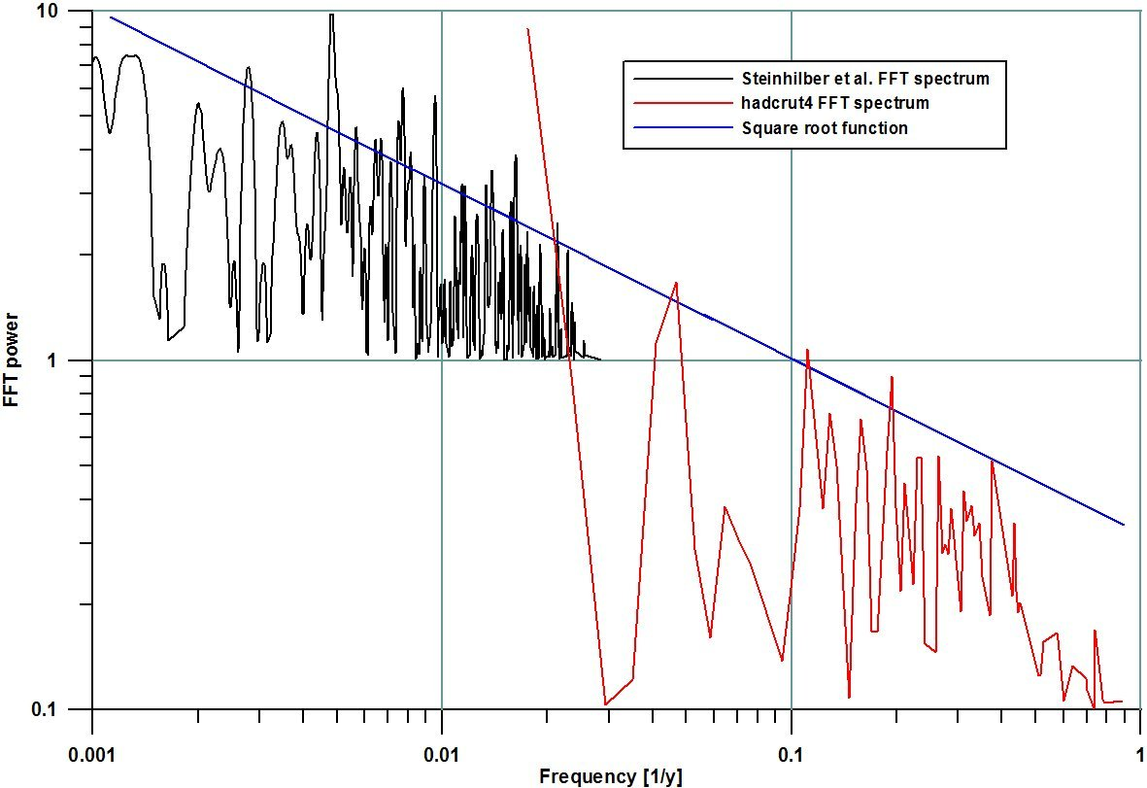

Figure 1 - Square root dependence of FFT analysed global temperature spectra after Steinhilber et al. and hadcrut4 data. Remarkable is a power peak at ~0.005 y⁻¹ , the frequency is about factor 5 higher then the peak near 0.0011 y⁻¹ or near a 900 year period.

So it takes no wonder that the power height of the Steinhilber et al. spectrum peak near the frequency of 0.001 periods per year or 1000 year period or around 900 years is strong, along with a strong power peak of 0.005 periods per year or around 200 years, which value is discussed in many published papers, like that from the Russian scientist [Habibullo I. Abdussamatov from 2012 [ http://icecap.us/images/uploads/abduss_APR.pdf ].
As Bond et al. have shown in 2001, the period of about 900 years is present back to 10000 years, and also E. Zorita et al. have published a global temperature reconstruction in the ECHO model.
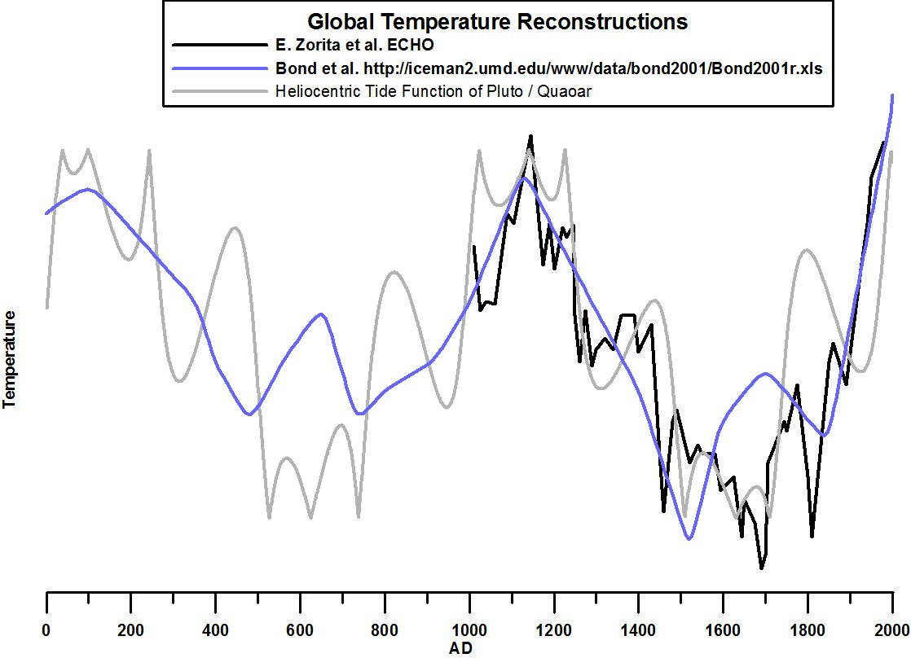
Figure 2 – Near 900 year main period from E. Zorita et al. in 2005 and from Bond et al. in 2001. Added is a heliocentric tide function of Pluto/Quaoar, which shows a non sinusoid character. Remarkable is the triple maxima and minima in the curve from E. Zorita et al., matching in with the heliocentric tide function in phase. The drop in the global temperature 1n 1815 is caused by the outbreak of the Tambore volcano ( VEI-7 event.)
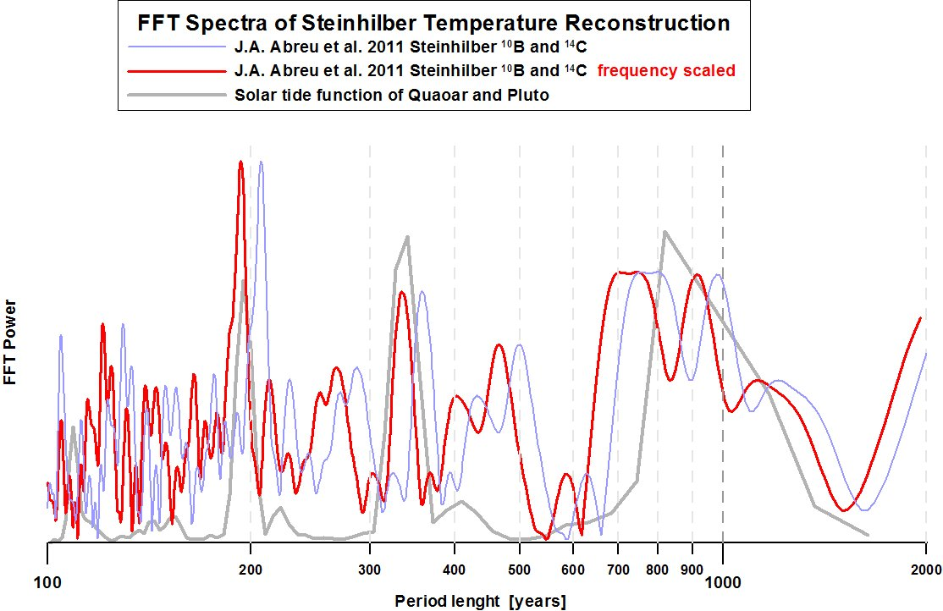
Figure 3 – The FFT spectra of the solar tide function of the couple Pluto/Quaoar shows beside the main power peak near a period of 900 years a strong power peak near 200 years and near 330 years. These three peaks are also present in the FFT spectra of the published temperature reconstruction of Steinhilber et al., if the time scale is shifted slightly with a calibration factor.

CULATING SYNODIC SOLAR TIDE FREQUENCIES
The synodic period of two planetary objects is simple the inverse of the difference of their eigen frequencies. The mean frequency of Pluto is 0.00403747 periods per year, and the mean frequency of Quaoar is 0.0034749 periods per year (or 1/247.68 years for Pluto and 1/287.7776 for Quaoar). The synodic frequency of both Pluto and Quaoar is f _{syn} = 0.00403747 – 0.00034749 = 0.000056257 periods per year, or 1/1777.557 years. The synodic tide frequency is then twice the synodic frequency with 2 x 0.000056257 = 0.00011251 periods per year or 1/888.778 years, which is near to the 900 year period. This discovery seems to be relevant, because the FFT analysis of the single tide function shows a ~200 year period power peak corresponding to the 5th harmonic to the main frequency.
Because of the extreme ellipticity of the Pluto path the common synodic trace of Pluto and Quaoar is modulated in its angle velocity on the ecliptic. The synodic tide function, which does not discriminate between a celestial opposition constellation and a celestial conjunction constellation inhibits therefore a strange function over time with spikes which extremes corresponding to the warm maxima and cold maxima of the global temperatures. Hereby the solar tide functions of ‘spring tides’ corresponding to warm times and the solar tide functions of ‘nip tides’ corresponding with cold times as shown in Figure 4.
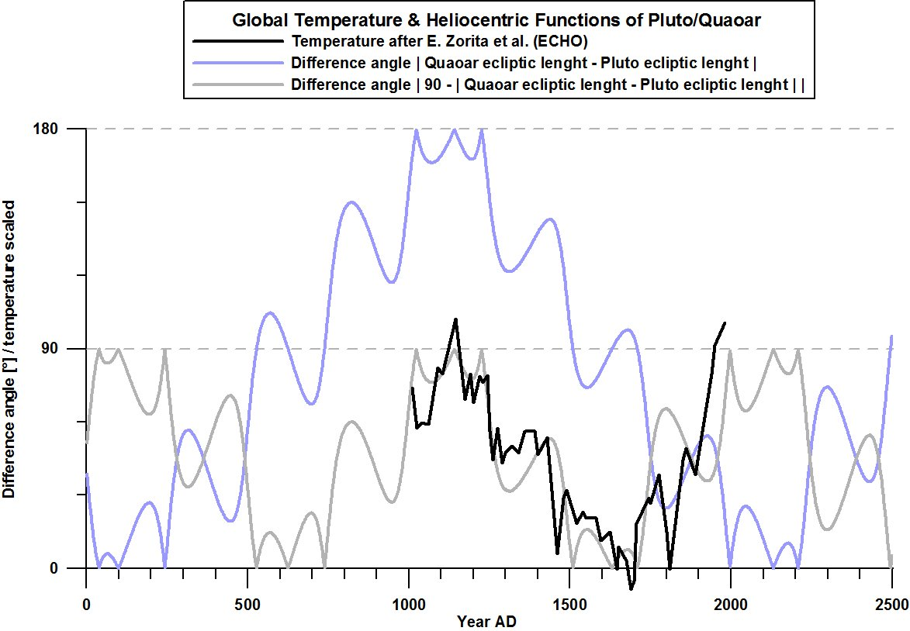
Figure 4 – Global temperature reconstructions like the data from E. Zorita et al. (ECHO) suggest that the synodic tide function of Pluto/Quaoar of about 900 year period is a better match than the synodic function of about 1800 year period. This becomes evident in the time of the ‘Little Ice Age’ after 1400 CE.

However, it is possible, that the time calibrations of the temperature reconstructions are not on the astronomical accuracy level. This becomes relevant, if a cross check of the FFT spectra from global temperature and synodic tide function of Pluto/Quaoar is done. If there is a different time calibration between the Steinhilber et al. temperature data and the astronomical time then the two FFT spectra show a remarkable match using a shift in time in the Steinhilber data in Figure 3. The possible calibration error in time in the reconstructed temperatures is a general problem in verification with astronomical functions. But on the other side it offers a new method to recalibrate the time scales of proxies to the astronomical accuracy level.
Because of the square root function of the strength of the FFT analysed temperature frequencies from the Steinhilber et al. data or from the Bond et al. data, the idea came up, to compute further 13 synodic solar tide couples, to check whether they fit into the reconstructed temperature spectra. For this idea some calculations were done with the amplitude of the 14 solar tide functions and its mean tide frequency f_{tide}. Here is an example for the tide couple Mars/Jupiter.
f _{tide} = 2 * (f _{p1} - f _{p2}), p1 = 'MA', p2 = 'JU', f _{MA} = 0.53166 [1/y], f _{JU} = 0.084317 [1/y]
f _{tide MA/JU} = 2 * (0.53166 - 0.084317) = 0.89469 periods/year
The tide strength s _{i} = k * (1/f _{tide i}) ^{0.5} ,
k = conversation factor: strength to temperature = 0.2
s _{i 1} = 0.2 * (1/0.89469) ^{0.5} = 0.21144

The result of this idea for 14 couples is shown in Figure 5.

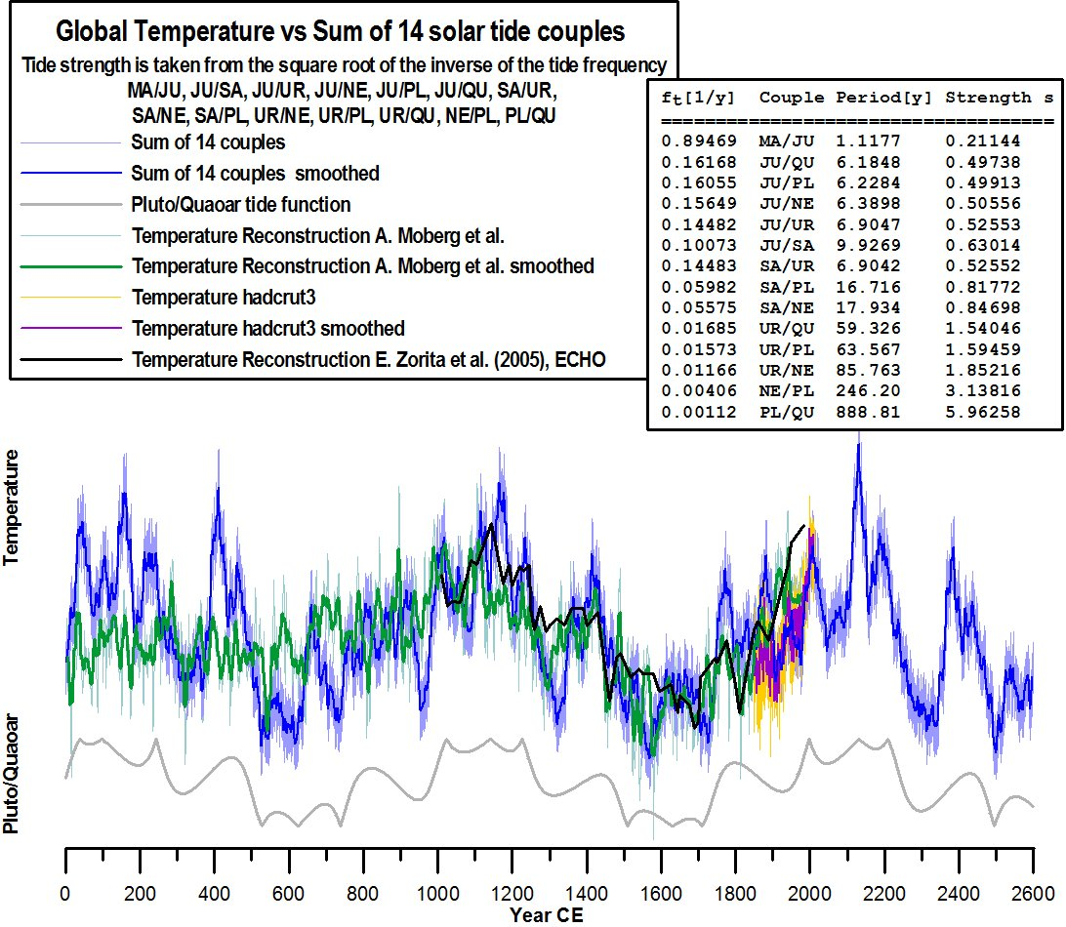
Figure 5 – The sum of the 14 solar tide functions is shown in light blue for the years of 0 CE to 2600 CE. The time increment of the astronomical heliocentric positions on the ecliptic is 30 days [http://www.volker-doormann.org/solar_tide_14.txt]. A smoothed curve is shown in dark blue. Because of the different functions in frequency and strength, the solar tide function of Pluto/Quaoar, shown in thick grey, is modified to a complex function. Beside the temperature reconstruction of E. Zorita et al. shown in black, the excellent temperature reconstruction of A. Moberg et al, is shown in thin gray; a smoothed curve is shown in thick green. Added is also the hadcrut3 temperature in thin orange after 1850 CE and a smoothed curve in magenta. The table in the inlet shows the solar frequencies and the used strength data for the summation of the 14 tide functions.
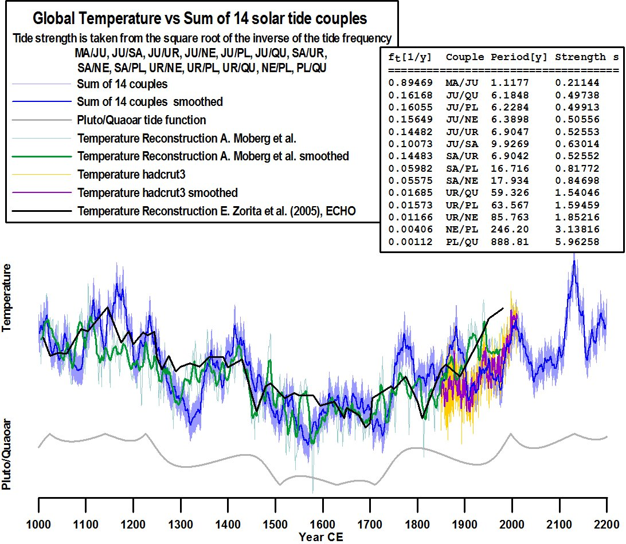
Figure 6 – Same curves as in Figure 5, but showing the blown up data from 1000 CE to 2200 CE.
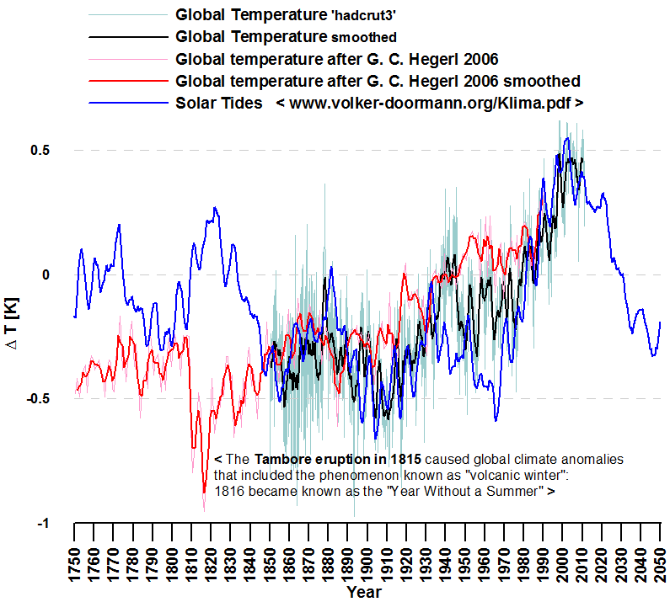
Figure 7 – Solar tides and global temperatures between 1750 AD and 2050 AD. The drop in the global temperature in 1815 is also visible in the spectrum after G. C. Hegerl from 2006.
Because of the delay in the Earth ocean resonances of MEI it is possible to remove the MEI function from the global temperature function [UAH] and can be compared with the solar tide function.
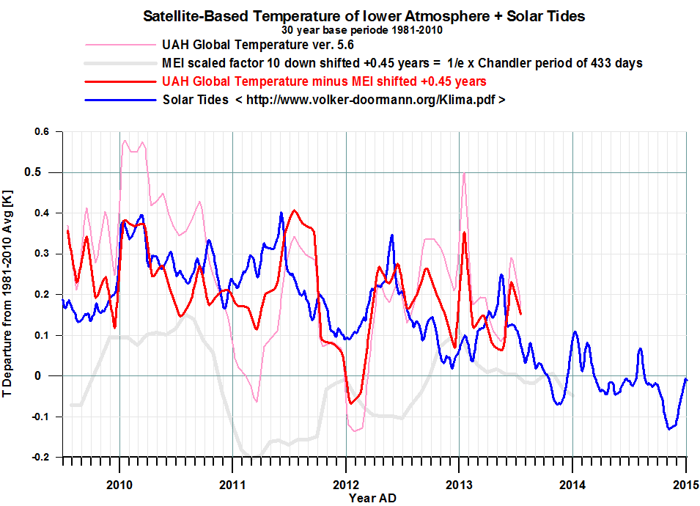
Figure 8 – Comparison of the removed delayed MEI function from the global temperature [UAH] and solar tide.

This is also done for the time window between 1955 and 1970 but the linear increase in both functions are removed (Fig. 9). Also shown the MEI scaled down by Factor 6.
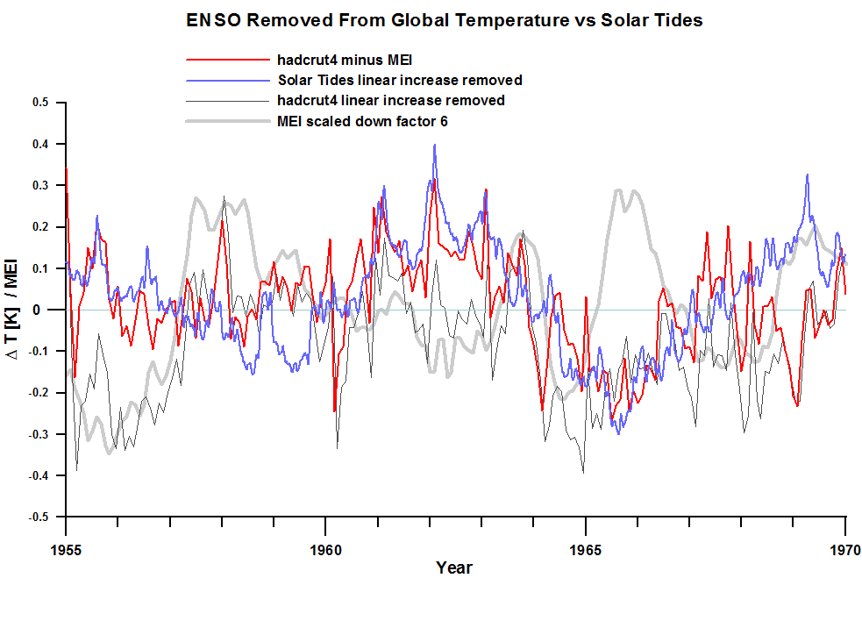
Figure 9 – Removing the Earth axis Chandler wobble sound of 433 day period and its sub harmonic modes indexed by the MEI (thick Gray) from the hadcrut4 oscillations (linear increase removed) shows a remaining temperature spectrum (Red) which is strong time coherent with the faster solar tides from Jupiter up in frequency. This means that the so called natural variation of the global temperature is an overlay of the solar tide effects and the impedance of the Earth axis wobble function.
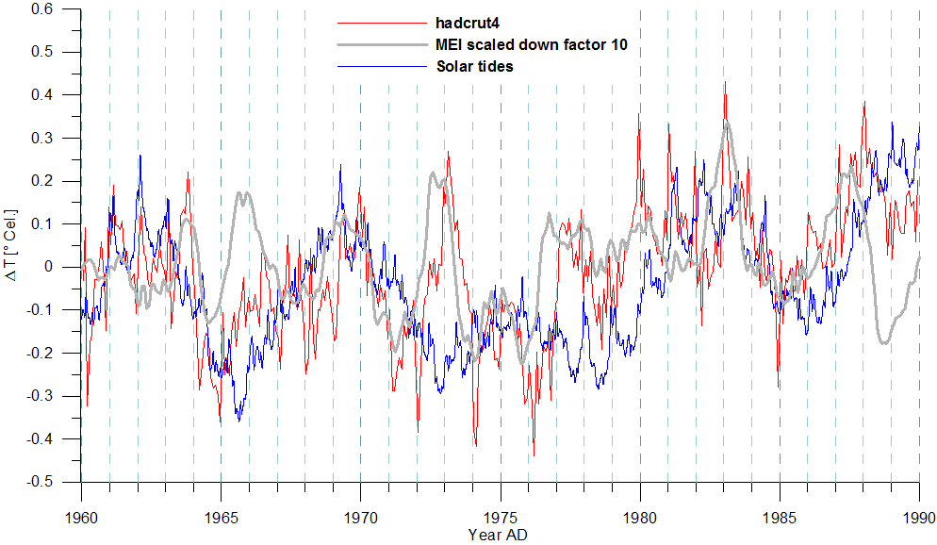
Figure 10 – Comparing a high frequency resolution of the solar tides inclusive Mercury etc. with the hadcrut4 spectrum it s well visible how the MEI as delayed by 0.44 years occurs in the global temperature.

While this investigations of the faster temperature frequencies it becomes clear that the measured global temperatures from REMSS or UAH cannot be explained in full only with solar tide functions, because of the complex impedances of the ocean oscillations like ONI or MEI. There are good reasons to assume that the global oscillation system are sub harmonics of the Earth wobble frequency after Chandler of 433/365.242 days = 1/1.1855 = 0.84352 years⁻¹, because there are 3 strong power peaks in the FFT analysed spectrum of MEI corresponding to sub harmonic modes of 0.42175 y⁻¹, 0.2811 y⁻¹ and 0.2101 y⁻¹, which are related to the sub harmonic mode numbers of 2, 3 and 4. In the end it seems that the Mei is superimposed to the solar tide functions, which can be confirmed with an available subtraction of the MEI function, time shifted by some month from the global temperature.

CONCLUSION
It has been shown that the known reconstructed global temperature data can be explained by synodic solar tide functions of planetary couples for the temperature frequencies and an square root function of the inverse of the synodic tide frequency for the strength of the temperature effect, as it is known from the FFT analysed known global temperature reconstructions. The solar tide functions of the solar tide couples fit well in phase and form with the known global temperature data. The main solar tide frequency of about ~1/900 years can be computed simple from NASA ephemeris back in time until 3000 BCE but also further in time until 3000 CE. This main solar tide frequency can be shown also in the temperature proxies after Bond et al. back for 1o ky in time.
With some logic it can be conclude that because of the first temperature maxima (of three) in February 1997 after every ~900 years that this main period will occur also in the future. Because of the character of the main function this would mean that the global temperature will decrease in the next decades followed by a time of increasing temperature about ~2100 CE on a higher temperature level than now, as it is visible in figure 6 and figure 7. The average stagnation of the global temperature since 1997, or since 16 years, can be seen as a confirmation of the main solar tide function of ~900 years at a maximum. Because of the dependence of the strength of the solar tide effects following a square root function, which is known from the FFT analysed temperature spectra of Bond et al. or Steinhilber, and because the analysed power peaks in the FFT spectra can be identified as higher harmonics of the main frequency peak of ~900 years, there is some evidence that the solar synodic tide function has a main impact on the global temperature.

It is not clear what the physical mechanism is, which is related to the solar tide and a variation in the heat of the sun, but Ching Che Hung [http://ntrs.nasa.gov/search.jsp?R=20070025111] has argued on this problem: “If Newton’s law of linear motion is used as a first-order approximation, then the distance an object (e.g., molecule or ion) could move (S) under the tide-driving gravity (g) over a time interval (T) is S = 0.5gT² . Therefore it is hypothesized that the changes of the solar activity caused by the tide-driving displacement of the hot plasma is proportional to the magnitude of the tide-driving gravity and to the square of the length of time when the active region is under the influence of the tide-driving gravity.”
This confirms the analysed inverse square root function of the tide frequencies analysed with FFT of the temperature proxies.

There are some more hints about a physical solar process in or on the Sun from the measured solar neutrino rate from the Homestake experiment or the Neutrino detector experiments in Japan. There is a weak positive correlation of the few data points corresponding to a high Neutrino rate with a higher global temperature on the earth. An further indication of this stuff is the correlation of the increasing global temperature on Earth with the increasing temperature on the planet Neptune in the last century.

A special thank to J. Kepler, who has me shown how to analyse astronomical functions.

